**Supplementary Result**

**Genomic featuresof *E. faecium* LR13**

The genome sequencing of *E. faecium* LR13 was conducted with a sequencing depth of ~400x which was sufficient for *de novo* assembly. Quality assessment of the reads revealed that Illumina sequencing data was optimal for assembly (**Link S1 & S2**) since ~95% of the reads aligned with the *E. faecium* genome (**Supplementary Table 1 (S1)**). After trimming, the Phred value of ~98% reads was >33 indicating a high quality (**Supplementary Table 1 (S2)**). The overlapping reads were further merged for a better assembly (**Supplementary Table 1 (S3)**). The final draft assembly showed 97 contigs of varying lengths. Nodes with length 200bp were discarded and 97 contigs with a length >200bp were selected for further analysis. Finally, the assembled genome showed 97 contigs, 37.79% GC content and a genome size of 2.66Mbp. The N50 value of 123,181 bp (**Table 1 & Supplementary Table 1 (S5)**). Thus, the assembled genome showed 99.63% completeness after marker gene analysis (**Supplementary Table 1 (S6)**). Within the genome, 2,522 protein-coding genes were identified, of which putative functions were annotated for 1,558 genes while 964 genes were annotated as hypothetical. Also, 18 pseudogenes, 1 tmRNA, 3 rRNAs and 56 tRNAs were annotated (**Table 1 & Fig. 1**). Genes encoding for proteins residing inside the cellular machinery were analysed through the RAST subsystem which revealed that 74% of the genes coded for metabolic proteins, protein processing, stress response, DNA & RNA processing and membrane transport, while 26% of the genes were poorly characterized (**Supplementary Fig. S1**). The KEGG Automatic Annotation Server (KAAS) revealed enrichment of proteins involved in carbohydrate metabolic pathways in *E. faecium* LR13.

**Fig 1:** Circular representation of *Enterococcus faecium* LR13 draft genome. The circles were generated using CG view server.

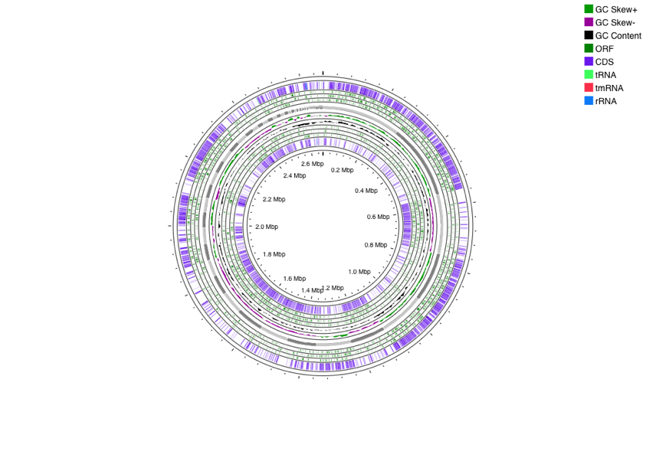

**Table1**: Genomic features of *E. faecium* LR13

|  |  |  |
| --- | --- | --- |
|  | **Features** | ***E. faecium* LR13, draft genome** |
| **Assembly** | Genome Length | 2,665,715 bp (2.66Mbp) |
| GC Content (%) | 37.79 |
| N50 | 123,181 |
| Largest Contig | 282,801bp |
| **Annotations** | No. of proteins | 2,522 |
| No. of Pseudogenes | 18 |
| No. of rRNAs | 3 |
| No. of tRNAs | 53 |
| **Genomic Signatures** | CRISPR array | 2 |
| No. of Prophages | 10 |
| IS Elements | 14 |
| **Reference** | GenBank Accession no. | JANRHE000000000 |